Past Events: 2010

“Searching for a Human Rights Strategy in the Arab Region”
A Presentation by Bahey El Din Hassan, the director of the Cairo Institute for Human Rights Studies in Cairo, Egypt

“Children and Transitional Justice: Truth-Telling, Accountability and Reconciliation”
A presentation featuring Archbishop Desmond Tutu (via videolink), with panelists Yasmin Sooka (Foundation for Human Rights, South Africa); Susan Bissell (UNICEF, Global Chief of Child Protection); Sharanjeet Parmar (Global Rights, Washington, D.C.); and Jens Meierhenrich (Harvard University, Department of Government)

“The UN and LGBT Rights: Obstacles and Opportunities”
A Presentation featuring Stefano Fabeni, Director of the LGBTI Initiative at Global Rights

“Worse Than War: Genocide, Eliminationism, and the Ongoing Assault on Humanity”
A film screening followed by a panel discussion with Prof. Alex Whiting (Harvard Law School) and author Daniel Goldhagen, moderated by Joshua Rubenstein, Northeast Regional Director for Amnesty International USA.

“Penal Coercion in Contexts of Unfair Inequality”
Presentation featuring Roberto Gargarella, Associate Senior Researcher with the Chr. Michelsen Institute (CMI) in Norway

“Special Tribunal for Lebanon: Selected Legal and Practical Issues”
A presentation featuring Daryl A. Mundis, Chief of Prosecutions at the Special Tribunal for Lebanon

“The Rise of Drones and Targeted Killings in US National Security Policy”
A Presentation featuring Philip Alston, Visiting Professor, Harvard Law School; John Norton Pomeroy Professor of Law, New York University School of Law

“Prosecuting War Crimes in Sri Lanka”
A presentation featuring Jim Ross, Legal and Policy Director at Human Rights Watch.

“Marriage Equality and Contemporary Politics in Argentina”
A Presentation featuring Ida Scherman, Professor of Law, University of Buenos Aires

“Pursuing Reconciliation in Iraq: The Art of Mediation Between Warring Religious Factions”
A Presentation Featuring Canon Andrew White, Recipient of the 2010 Civil Courage Prize

Financing Freedom: Human Rights and the Risks and Responsibilities of Global Finance
A Presentation Featuring David Kinley, Chair in Human Rights Law, University of Sydney

“Hunger as Politics: The Right to Food and Global Security”
A special workshop with Olivier de Schutter, the UN Special Rapporteur on the Right to Food, who will discuss his mandate and global right to food challenges

“Mobilizing for Human Rights: International Law in Domestic Politics”
A book talk by Professor Beth Simmons, Clarence Dillon Professor of International Affairs at Harvard University.

“A Dialogue with China on Human Rights: A Personal Odyssey”
A Presentation Featuring John Kamm, Founder and Executive Director of the Dui Hua Foundation

“The Ergenekon/Sledgehammer Trials and the Rule of Law in Turkey”
A talk by Professor Dani Rodrik of the Harvard Kennedy School

“Stones of Hope: How African Activists Reclaim Human Rights to Challenge Global Poverty”
A dialogue between Duncan Kennedy (Carter Professor of Jurisprudence, Harvard Law School) and Jeffrey Sachs (Director, Earth Institute, Columbia University; Special Advisor to United Nations Secretary).

“Ethnic/Religious-Based Admission Criteria in British and Israeli Schools: Comparative Judicial Perspectives Ethnic/Religious-Based Admission Criteria in British and Israeli Jewish Schools”
A talk by Reuven Ziegler, visiting professor from the University of Oxford

Past Events: 2009

“You're Not Universal and Stop Whining About it: Sexuality and the Limits of Human Rights”
This event featured Scott Long, Director of the Lesbian, Gay, Bisexual and Transgender Rights Program at Human Rights Watch.

“Invisible Citizens: The Bedouin of the Negev”
This panel presentation featured Yeela Raanan, Regional Council for the Unrecognized Villages; college professor in the Negev; Khalil Alumur, Representative of the local committee in Alsirri Village, an unrecognized village in the Negev; and Ahmad Amara (Moderator), Global Advocacy Fellow and Clinical Instructor with the International Human Rights Clinic at Harvard Law School.

“Building a New House: Women, the UN and Gender Architecture”
This event featured Cynthia Rothschild, a former Senior Policy Advisor with the Center for Women's Global Leadership at Rutgers University.

“Exploring Social Rights”
This panel presentation coincided with the launch of "Exploring Social Rights," a book edited by Aeyal Gross and Daphne Barak-Erez.

“State, Churches and Freedom of Conscience: Why the French Laicite is Liberal”
This event featured Professor Patrick Weil, a Visiting Professor of Law and Robina Foundation International Fellow at Yale Law School and Director of the Center for the Study of Immigration, Integration and Citizenship Policies at the University of Paris, Pantheon-Sorbonne.

“Human Rights Diplomacy: An Oxymoron?”
A presentation by Navi Pillay, the UN High Commissioner for Human Rights. Judge Pillay was an attorney and conveyancer of the High Court of South Africa from 1967 to 1995, and was appointed acting judge of the High Court in 1995.

“The Unheard Truth: Poverty and Human Rights”
A presentation by Amnesty International Secretary General Irene Khan, who made the case that poverty remains a global epidemic because we continue to define it as an economic problem whose only solution is foreign aid and investment.

“Litigating the Right to Water in South Africa: The Mazibuko Case”
A presentation by Professor Jackie Dugard of the University of the Witwatersrand in Johannesburg.

“Reproductive Rights and the Right to Information”
This event addressed the role that access to information for marginalized women plays in their reproductive health and lives, looking at how this issue impacts poor women, women of color, and adolescents among other populations.

“Engaging a Pariah: How the ILO Used International Law to Tackle Forced Labor in Burma”
A presentation by Richard Horsey, the former International Labor Organization (ILO) representative in Burma.

“International Criminal Justice: Challenges of Investigating and Prosecuting War Crimes”
A talk by Serge Brammertz, the Chief Prosecutor for the International Criminal Tribunal for the former Yugoslavia (ICTY).

“Prosecuting Heads of State”
A presentation by Ellen Lutz, Executive Director of Cultural Survival and the co-editor of the 2009 book, Prosecuting Heads of State

“Multi-Disciplinary Perspectives on National Human Rights Institutions, State Compliance and Social Change”
This workshop responded to a number of converging developments as human rights advocates turn their attention away from an increasingly ambitious and sophisticated international human rights normative framework toward its effective implementation at the national level.

“Children and Transitional Justice”
Co-convened by the UNICEF Innocenti Research Centre and the Human Rights Program at Harvard Law School, this conference brought together scholars, UN officials and practitioners to review and consolidate documentation, research and analysis of the legal framework, thematic issues and case studies on children and transitional justice. A main goal of the conference was to build consensus on a key principles document for the protection of the rights of child victims and witnesses participating in transitional justice mechanisms and processes. Research shared at the conference will formed the basis of a Fall 2009 Human Rights Program book, distributed by Harvard University Press, titled, "Children and Transitional Justice: Truth-Telling, Accountability, and Reconciliation."

“Learning from the Rwandan Genocide, Remembering Alison Des Forges: Perspectives on Her Life and Work”
This event honored the life of human rights advocate Alison Des Forges, former senior advisor for the African Continent for Human Rights Watch and an expert in the 1994 Rwandan Genocide. Panelists for this event included: Catharine Newbury (Professor of Government, Smith College); Lindsey Hilsum (International Editor, Channel 4 News, UK); Barbara Mulvaney (Former Prosecutor, UN International Criminal Tribunal for Rwanda); and Noel Twagiramungu (Tufts University).

“The Challenge of Accountability: A Conversation with Major General Antonio Taguba”
This event featured Major General Antonio Mario Taguba, a retired general in the U.S. Army, and the author of the 2004 "Taguba Report," an internal U.S. Army report on detainee abuse at Abu Ghraib prison in Iraq.

“Reproductive Health and Rights in the Middle East and North Africa: Exploring Myths, Realities, Opportunities and Challenges”
This event featured Dr. Angel Foster, a Senior Associate with Ibis Reproductive Health.

“The United Nations Convention of Persons with Disabilities: A Paradigm Shift”
This event featured HLS Wasserstein Fellow Tanya Smith, Human Rights Officer with the UN Office of the High Commissioner for Human Rights (UNHCR).

“Globalization and Public Interest Litigation in India”
This event featured Colin Gonsalves, the Founder of the India Center for Human Rights Law.

“Interrogations, Forced Feedings, and the Role of Health Professionals”
This event commemorated a Harvard University Press publication by the Human Rights Program, and featured four panelists who contributed to the volume: Scott Allen, Assistant Professor (Clinical) Medicine, Brown University; Robert Jay Lifton, Lecturer on Psychiatry, Harvard Medical School; Stephen Soldz, Director of the Center for Research, Evaluation, and Program Development at the Boston Graduate School of Psychoanalysis; and Leonard Rubenstein, President and former Executive Director, Physicians for Human Rights.

“Speak Frankly About Torture: Exercising International Citizenship”
This event featured Darius Rejali, professor of political science at Reed College and an internationally recognized expert on modern torture.

“New Media, Traditional Communications and Human Rights Advocacy”
This panel looked at strategies for communicating about human rights issues, and how changing media has influenced the ways in which human rights advocates do outreach and get out their message. Panelists included: Sameer Padania (WITNESS); Barbara Becker (EqualShot Communications); and Michael Jones (Communications Director of the Human Rights Program @ Harvard Law School and Gay Rights editor of change.org).

Past Events: 2008

“International Law and its Challenges: Advocacy Strategies in the Middle East”
This event featured Sarah Leah Whitson, Director of the Middle East and North Africa Division for Human Rights Watch.

“National Human Rights Institutions and the Domestication of International Law”
As part of the Human Rights Program’s thematic concentration on National Human Rights Institutions (NHRIs), this luncheon presentation featured Richard Carver, Associate Lecturer at the Centre for Development and Emergency Practice at Oxford Brookes University in England.

“The U.S. and Human Rights: What Difference Would a National Institution Make?”
In a celebration of the 60th anniversary of the UN Declaration of Human Rights, a panel of leading human rights experts discussed what difference a national human rights institution might make for the United States. The panel consisted of: Chris Stone, Daniel and Florence Guggenheim Professor of the Practice of Criminal Justice at the Harvard Kennedy School of Government; Robin Toma, Executive Director of the Los Angeles County Human Relations Commission; Yvonne Johnson, Mayor of Greensboro, North Carolina; and Richard Carver, Associate Lecturer at the Centre for Development and Emergency Practice at Oxford Brookes University in England.

“The International Court of Justice and Enforcement of Human Rights Law: Reflections from the Georgia v. Russia Case”
A presentation by Payam Akhavan, Professor of International Law at McGill University, who spoke about his role as counsel for Georgia in the International Court of Justice case against Russia.

“Can Democracy Survive Prolonged Occupation and War on Terror?”
The panelists for this event included: Adv. Michael Sfard, Legal Counsel, Yesh Din (Volunteers for Human Rights); Adv. Sari Bashi, Director, Gisha (Center for the Legal Protection of Freedom of Movement); Adv. Limor Yehuda, Director of Occupied Territories Program (Association for Civil Rights in Israel); and Dr. Amir Paz-Fuchs, Board Member, Bimkom (Planners for Planning Rights).

“Testing Transitional Justice”
This event featured former HRP Visiting Fellow Pierre Hazan, formerly a Fellow with the U.S. Institute of Peace, and a UN correspondent for numerous media outlets.

“Milosevic, Taylor and al-Bashir: Is Justice Possible for Chiefs of State?”
This event featured Stephen Rapp, prosecutor of the Special Court for Sierra Leone.

“Dialogical Justice and the Protection of Social Rights”
This event featured Roberto Gargarella, Tinker Visiting Professor at Columbia University for Fall 2008 at the Institute of Latin American Studies and Professor of Constitutional Theory and the Philosophy of Law at the Universidad Torcuato Di Tella in Buenos Aires, Argentina.

“The Intent to Destroy in Whole or in Part: Legal Concepts of Genocide from the ICTY, ICTR and the Bosnian ICJ-Genocide Case”
This event featured Phon van den Biesen, who since 1993 has been Deputy Agent for Bosnia and Herzegovina at the International Court of Justice in the Hague in Bosnia’s genocide-case against Yugoslavia.

“The Right to Health: Lessons from HIV/AIDS”
This event featured Anand Grover, the new UN Special Rapporteur on the Right to Health.

“Lawyering in the War on Terror”
A presentation by Alberto Mora, a retired General Counsel of the U.S. Navy, who vigorously pressed the Bush Administration to prevent military and civilian leaders from codifying policies that could implicitly and explicitly sanction the maltreatment of Guantanamo detainees as part of the War on Terror.

“Broken Laws, Broken Lives: Medical Evidence of Torture by the United States”
Two staff members of Physicians for Human Rights (PHR) discussed their in-depth evaluation into deliberate human rights violations by the U.S of political detainees. The event featured Farnoosh Hashemian, lead author for the report and research associate at PHR, and Nathaniel Raymond, a senior communications strategist at PHR.

“Guantánamo and the First 100 Days: The Way Forward”
An event featuring Emi MacLean, who has worked at the Center for Constitutional Rights (CCR) with the Guantánamo Global Justice Initiative (GGJI) since June 2006.

“Iraq, Afghanistan, Lebanon, Somalia and the U.S. War on Terrorism”
This event featured Nir Rosen, a journalist and fellow with the NYU Center on Law & Security.

“The War on Terror and Human Rights Law in the U.K.”
A presentation by Former Kennedy scholar Shaheed Fatima, currently a barrister at Blackstone Chambers, who has served as council to many post-9/11 cases, both before the House of Lords and the European Court of Human Rights.

“The Iraq History Project: Personal Narratives on Political Violence Before and After the U.S. Invasion”
This event featured Etelle Higonnet, Analysis Director of the Iraq History Project. Higonnet has worked for UNICEF and other human rights NGOs and has also served under two war crime tribunals.

“International Criminal Justice: Does it Work?”
A presentation by Judge Theodor Meron, the Charles L. Denison Professor of Law at NYU and Judge of the International Criminal Tribunal for the former Yugoslavia.

“Litigating the Right to Health”
This event featured Siri Gloppen, an associate professor at the University of Bergen and a Senior Researcher at the Chr. Michelsen Institute, whose research focuses on rights, democracy and development in Africa.

“Out of Place: The Bedouins of the Negev Under Israeli Law”
This event featured Dr. Alexandre Kedar, a faculty member of the Law School at Haifa University whose research focus is on legal geography, legal history, and land regimes in settler societies and in Israel.

“Health and Human Rights: Creating an Open Forum to Advance Global Health and Social Justice”
This panel event celebrated the launch of the online journal Health and Human Rights. Speakers and panelists included Drs. Paul Farmer and Jim Yong Kim; Philip Alston (NYU Law School); Agnes Binagwaho (Rwanda National AIDS Control Commission); and Gavin Yamey (PLoS Medicine).

Past Events: 2007
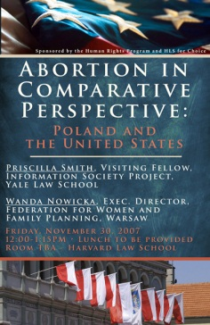
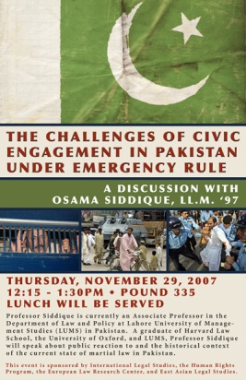
“Abortion in Comparative Perspective: Poland and the United States”
This event, co-sponsored by the Human Rights Program and HLS for Choice, was the first in a series of events looking at comparative perspectives on abortion. This event looked specifically at Poland and the United States, and featured Priscilla Smith (Visiting Fellow with the Information Society Project at Yale University), and Wanda Nowicka (Executive Director of the Federation for Women and Family Planning in Warsaw).
The Challenges of Civic Engagement in Pakistan Under Emergency Rule
This event featured HRP alum Osama Siddique, LL.M. '97, a Professor in the Department of Law and Policy and the Lahore University of Management Studies (LUMS) in Pakistan. Professor Siddique spoke about public reaction to and the historical context of the state of martial law in Pakistan, and focused on recent political and judicial developments.
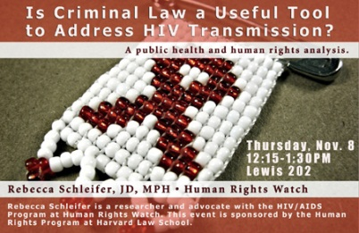
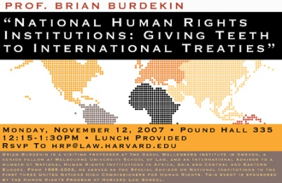
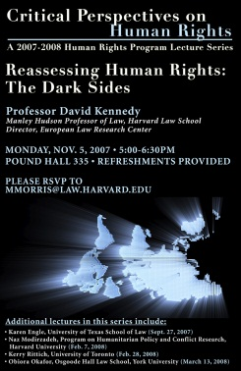
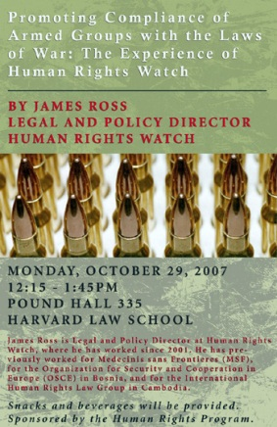
“Is Criminal Law a Useful Tool to Address HIV Transmission?”
This event featured Rebecca Schleifer, JD, MPH, a research and advocate with the HIV/AIDS Program at Human Rights Watch, who offered a health and human rights analysis on whether criminal law is a useful tool to address HIV transmission and explored international and domestic law on HIV/AIDS.
“National Human Rights Institutions: Giving Teeth to International Treaties”
This event featured Professor Brian Burdekin, Visiting Professor at the Raoul Wallenberg Institute in Sweden and a Senior Fellow at Melbourne University School of Law. Burdekin focused on the legitimacy of National Human Rights Institutions and their development over the past ten years, as well as his own experiences in working with National Human Rights Institutions in Asia and Africa.
“Reassessing Human Rights: The Dark Sides”
This presentation by Professor David Kennedy (Harvard Law School), as the second in a yearlong series, "Critical Perspectives in Human Rights." The series features scholars producing work that critically examines the study and practice of human rights. Professor Kennedy discussed the ideology, ethics, strategies, and consequences of international human rights promotion and practice, based on sections of his book, The Dark Sides of Virtue: Reassessing International Humanitarianism.
Other speakers in this series include Karen Engle (University of Texas at Austin Law School), Naz Modirzadeh (Program on Humanitarian Policy and Conflict Research at Harvard University), Kerry Rittich (University of Toronto), and Obiora Okafor (Osgoode Hall Law School).
“Promoting Compliance of Armed Groups with the Laws of War: The Experience of Human Rights Watch”
This event featured James Ross, Legal and Policy Director at Human Rights Watch in New York. Ross talked about his own experience, as well as that of Human Rights Watch, in working with armed groups to understand and comply with the laws of war. Ross previously worked for Medicins Sans Frontieres (MSF), for the Organization for Security and Cooperation in Europe (OSCE) in Bosnia, and for the International Human Rights Law Group in Cambodia.

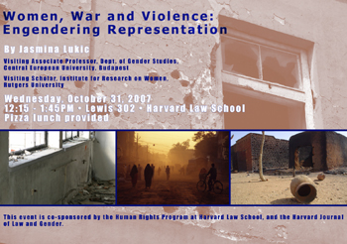
Women, War and Violence: Engendering Representation
This event featured Jasmina Lukic, Associate Professor with the Department of Gender Studies at Central European University in Budapest, and for 2007-2008 is serving as a Visiting Fellow with the Institute for Research on Women at Rutgers University. Co-sponsored by the Journal on Law and Gender, Lukic used film as a means of analyzing the role of war and violence on women.
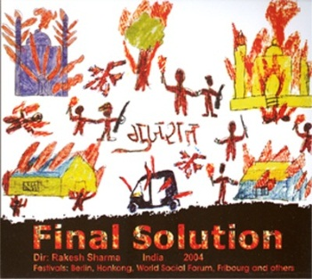
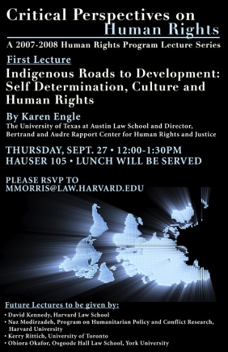
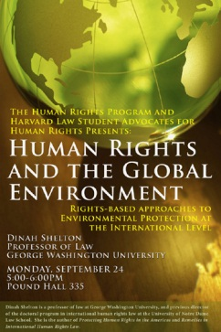
“Final Solutions”
This film screening and discussion centered on the film "Final Solutions," which is set in Gujarat, India during February 2002-July 2003. The film graphically documents the changing face of right-wing politics in India through a study of the 2002 genocide of Muslims in Gujarat. Members of the Human Rights Program's International Human Rights Clinic facilitated discussion, and the event was co-sponsored by the South Asian Law Students Association.
“Indigenous Roads to Development: Self Determination, Culture and Human Rights”
This presentation by Professor Karen Engle (University of Texas at Austin Law School) was the first in a yearlong series sponsored by the Human Rights Program, "Critical Perspectives on Human Rights," examining critical issues in the study of human rights. Prof. Engle is the Director of the Bertrand and Audre Rapport Center for Human Rights and Justice.
Other speakers in this series include David Kennedy (Harvard Law School), Naz Modirzadeh (Program on Humanitarian Policy and Conflict Research at Harvard University), Kerry Rittich (University of Toronto), and Obiora Okafor (Osgoode Hall Law School).
“Human Rights and the Global Environment: Rights-based Approaches to Environmental Protection at the International Level”
This event by Prof. Dinah Shelton, the Patricia Roberts Harris Professor of law at George Washington University, focused on linking human rights and environmental protection by looking at the history of this linkage, the gaps, and the problems that states and institutions face when addressing human rights and the environment.

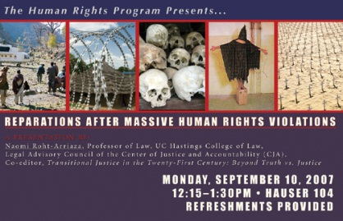
Reparations After Massive Human Rights Abuses
This presentation by Naomi Roht-Arriaza, Professor of Law at UC Hastings, examined the budgeting, planning and restitution of goods of countries handling reparations and the problems and benefits that arise.

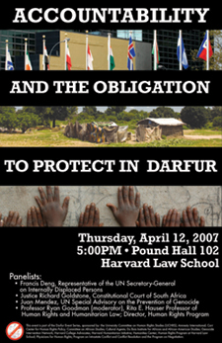
The Iraqi Refugee Crisis
Since its inception, the Iraq War has provoked worldwide debate on issues of sovereignty, responsibility and the legitimacy of international law. These topics continue to be relevant when discussing the alarming number of civilians who have been displaced by the conflict. As of April 2007, 3.8 million people have been uprooted from their homes, many of them fleeing to neighboring countries, as well as to the United States, for refuge. During this presentation, Human Rights Watch's Refugee Policy Director, Bill Frelick, talked about the situation for refugees and displaced persons in Iraq.
“Accountability and the Obligation to Protect in Darfur”
This event was the seventh in a yearlong series of events on Darfur, organized by the University Committee on Human Rights Studies (UCHRS) and co-sponsored by the Human Rights Program. This panel focused on how countries and international bodies are reacting or not acting to the crisis in Darfur, and also addressed questions including international litigation, the potential use of force in Darfur, sanctions, and more. Panelists included Francis Deng, Representative of the UN Secretary-General on Internally Displaced Persons, Justice Richard Goldstone, Constitutional Court of South Africa, and Juan Mendez, UN Special Adviser on the Prevention of Genocide. The panel was moderated by Professor Ryan Goodman, Rita E. Hauser Professor of Human Rights and Humanitarian Law at Harvard Law School, and Director of the Human Rights Program.
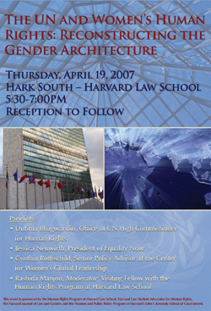
“The UN and Women's Human Rights: Reconstructing the Gender Architecture”
This panel event featured commentary on the creation of the UN Office of the Special Advisor on Gender Issues and Advancement of Women, and the current work of the office as well as the Committee on the Elimination of Discrimination Against Women. Panelists included: Dutima Bhagwandin, Office of the UN High Commissioner for Human Rights; Jessica Neuwirth, President of Equality Now; and Cynthia Rothschild, Senior Policy Advisor at the Center for Women's Global Leadership. The panel was moderated by Rashida Manjoo, HRP Visiting Fellow and former Commissioner of South Africa's Commission on Gender Equality.
“Private Military Contractors: Rights, Risks and Regulations”
This presentation by Prof. Kateri Carmola, CA Johnson Fellow in Political Philosophy at Middlebury College, focused on the growing use of private security contractors worldwide, and the ethics and laws of war, especially in current conflicts.
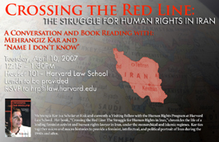
“Crossing the Red Line: The Struggle for Human Rights in Iran”
This event featured a conversation and book reading with HRP Visiting Fellow and Scholar at Risk Mehrangiz Kar, and Afsaneh Najmabadi, Professor of History and Women's Studies at Harvard. Kar's book, "Crossing the Red Line: The Struggle for Human Rights in Iran," chronicles the life of a leading feminist activist and human rights leader in Iran, under the monarchical and Islamic regimes. Kar ties together micro and macro histories to provide a feminist, intellectual, and political portrait of Iran during the 1960s and after.
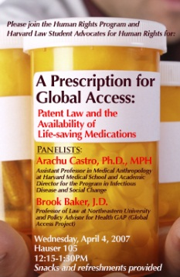
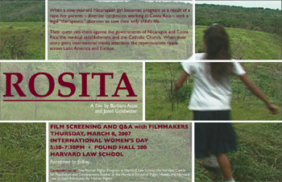
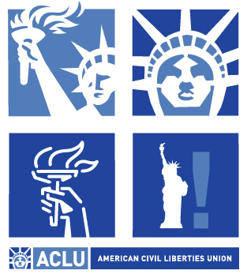
A Prescription for Global Access: Patent Law and the Availability of Life-saving Medications
This panel focused on trade and intellectual property issues and their impact on the availability of life-saving medicines around the globe. Panelists included Arachu Castro, PhD, MPH, Assistant Professor in Medical Anthropology at Harvard Medical School and Academic Director for the Program in Infectious Disease and Social Change; and Brook Baker, JD, Professor of Law at Northeastern University and Policy Advisor for Health Gap (Global Access Project).
“Human Rights Enforcement in Post-Apartheid South Africa”
This presentation and Q & A featured Jody Kollapen, Chair of the South Africa Human Rights Commission. Commissioner Kollapen joined the Commission in December 1996, and has worked on political cases such as the Sharpeville Six, the Delmas Treason Trial, and the failure of the Medical and Dental Council to inquire into the behavior of doctors who treated Steve Biko.
“Rosita: An Award-winning film from Barbara Attie and Janet Goldwater”
This film presentation by filmmaker Janet Goldwater chronicled the story of a nine-year-old Nicaraguan girl who has become pregnant as the result of rape. In both Nicaragua and Costa Rica, abortion is illegal except when deemed necessary to save the life of the mother. Despite the odds of obtaining a rarely granted exception for a so-called "therapeutic" abortion, Rosa's parents move forward only to be forced into battle with two governments, the medical establishment, and the hierarchy of the Catholic Church.
“Using Human Rights Law to Defend Civil Liberties at Home”
This event featured a presentation by Ann Beeson, ACLU Associate Legal Director of Programs on National Security and Human Rights. Beeson spoke to students about the ACLU's efforts to prevent the erosion of civil liberties in the name of national security, drawing upon her experience of winning an historic lawsuit on behalf of prominent journalists, scholars and attorneys challenging the National Security Agency's illegal surveillance of Americans without a warrant.
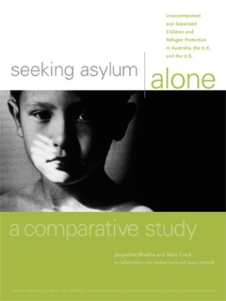
“Seeking Asylum Alone: Unaccompanied and Separated Children and Refugee Protection in Australia, U.K., and the U.S.”
This panel, moderated by Clinical Professor Debbie Anker, featured presentations by Mary Crock, University of Sydney Law School, and Jacqueline Bhabha, Harvard Law School and the Harvard University Committee for Human Rights Studies, on their new report, "Seeking Asylum Alone: Unaccompanied and Separated Children and Refugee Protection in Australia, U.K., and the U.S." The reports document the treatment of unaccompanied and separated children in refugee protection in the three countries, and includes a comparative study.
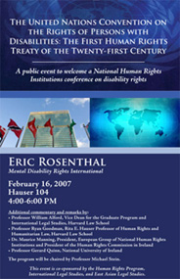
“The United Nations Convention on the Rights of Persons With Disabilities: The First Human Rights Treaty of the Twenty-first Century”
The Human Rights Program, International Legal Studies, and East Asian Legal Studies hosted this public lecture to welcome a National Human Rights Institutions Conference on disability rights. The keynote presentation was given by Eric Rosenthal, founder and executive director of Mental Disability Rights International, who emphasized the implications for advocacy on behalf of individuals with intellectual and psycho-social disabilities.
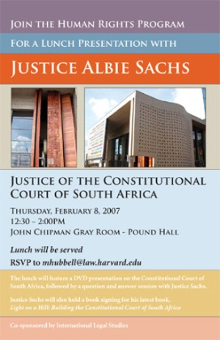
“A Lunch Presentation with Justice Albie Sachs, Constitutional Court of South Africa”
This luncheon presentation by Justice Albie Sachs focused on the rich history and meaning behind the construction of the Constitutional Court of South Africa, and included a DVD presentation and question and answer session.
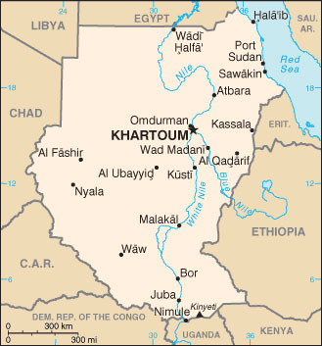
“Public International Law in Practice: Insights from Work in the Field”
In this presentation, Susan Page, JD '89, shared her insights from nearly twenty years in the field of public international law. Page has worked for the U.S. Department of State, the U.S. Agency for International Development, and the United Nations Development Program.

