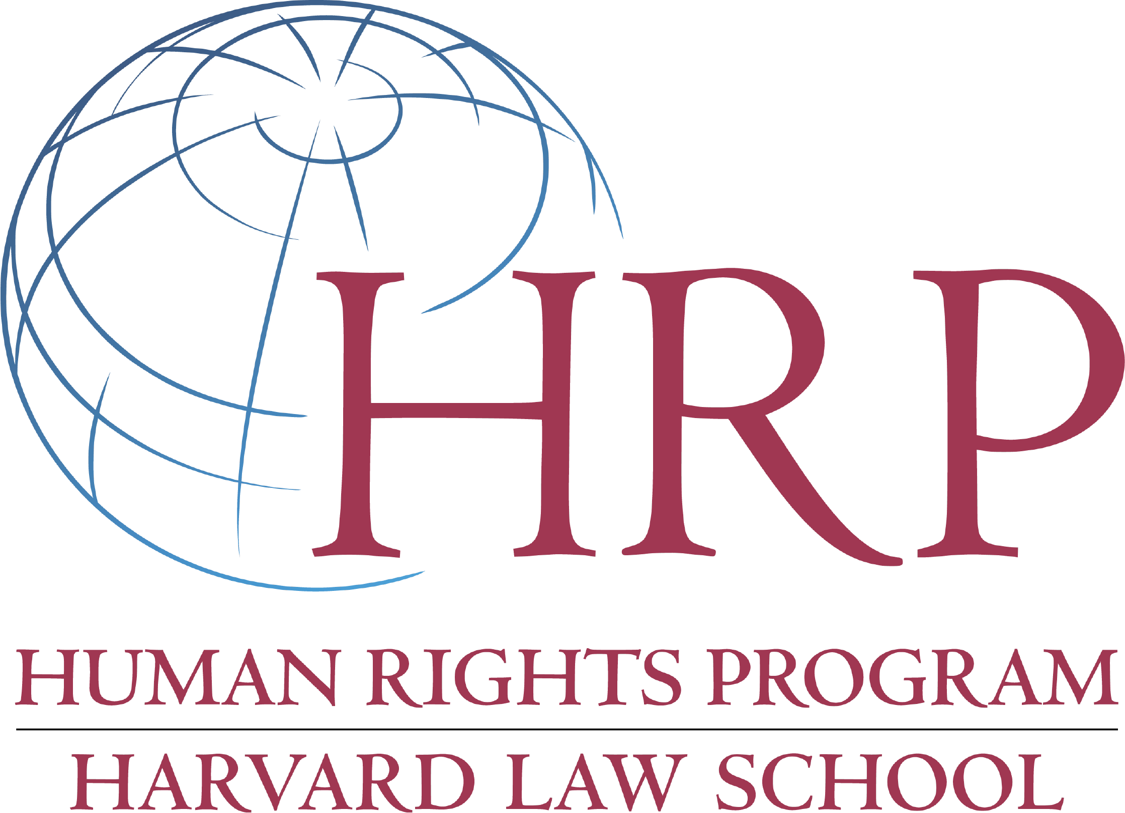
Henigson Human Rights Fellowship

The deadline for submitting applications for
the 2018-2019 Henigson Fellowship is March 19, 2018.

Description and Purpose of the Fellowship
The Human Rights Program (HRP) at Harvard Law School (HLS) is currently accepting applications for the Henigson Human Rights Fellowship for the 2018-2019 academic year. HRP will award between one and three fellowships to graduating LLMs, JDs, or recent alumni currently holding clerkships or public interest fellowships.

The Henigson Fellowship was made possible by a generous gift from Robert and Phyllis Henigson. The fellowship is awarded annually to present HLS students or recent graduates with a demonstrated commitment to international human rights. It supports individuals with an interest in exploring a career as an academic, activist, official, or practitioner in which human rights plays a significant role.
The Henigson Fellowship supports ten to twelve months of work in the developing world, usually with a nongovernmental organization (NGO). Each full fellowship carries a stipend of $27,000 and $1,500 toward international health insurance.

Eligibility
Eligible Individuals: 3Ls and LLMs expecting to receive a degree in June 2018 are eligible. Recent JD and LLM graduates are also eligible if they (i) have been clerking for a judge since graduation; (ii) have been engaged in full-time public interest work since graduation; or (iii) were active in human rights or public interest work while students at HLS. HLS JD and LLM 2018 graduates are given preference for the Henigson Human Rights Fellowship. Similarly, applicants who have not received previous post-graduate fellowship funding from HLS are given preference.

Eligible Locations: Fellowships will be awarded only for projects that are located in low or middle-income countries in the developing world. Placements in Australia, Canada, Japan, New Zealand, United States, Western Europe, and other similarly situated countries are not eligible. HRP will, however, consider applications that link work in the developing world with organizations in developed countries, so long as the focus of the work and the bulk of the time spent will be in the developing country.

Fellowships for projects in a candidate’s home country are discouraged.

The eligibility determination about a location will be made by HRP on a case-by-case basis.

Eligible Organizations: The fellowship contemplates active participation in NGOs working on human rights. The fellowships are not intended for scholarly research or to permit research at an academic institution. Applicants must have a sponsoring organization or organizations for a single project in the developing world. The organizations must be engaged in “human rights” as broadly defined. In most cases, these NGOs will be involved in human rights education, monitoring, reporting, litigation, grassroots mobilization, or advocacy. Organizations involved in human rights work in general or in specific areas of the human rights movement, such as women’s rights, children’s rights, labor rights, or refugees are good placements.

Qualifying NGOs may also include organizations working to embrace new and interdisciplinary directions in the rights movement. For example, organizations involved in economic development, humanitarian relief, or health or environmental advocacy that are pursuing a rights-based approach may also be eligible placements. Not every organization involved in environmental protection, economic development, public health, conflict resolution or peace studies, however, would qualify as a human rights organization.

The Selection Committee may, in rare special circumstances, award a fellowship for work within a governmental or intergovernmental human rights organization.

The eligibility determination for organizations will be made by HRP on a case-by-case basis.

Application
Applications should be submitted to HRP by March 19, 2018 to hrp@law.harvard.edu. A complete application will consist of the following:

- Curriculum vitae, including information about classes, work, and extracurricular activities in public interest and human rights inside and outside HLS;

- A personal statement (500 words maximum) about the applicant’s relevant experience, interest, and future aspirations with respect to public interest and human rights work. The statement should include a discussion of how the fellowship fits within the applicant’s career plans. The statement should clearly indicate whether the applicant wants to be considered for the Hengison Fellowship only, or for both the Satter and Henigson Fellowships.;

- A project description (see below for project requirements) including:

  - a description of the sponsoring organization and of its work in the local and international context;
  - a detailed discussion of the applicant’s project and its relation to the work of the organization; and
  - an estimated project budget to demonstrate feasibility;

- A letter and supporting material from the sponsoring organization detailing their purpose, function, and their particular interest in the work of the applicant;

- Two or three letters of recommendation, including at least one from a HLS professor; letters of recommendations may be submitted separately from the rest of the application to hrp@law.harvard.edu; and

- HLS transcript.

Fellowship Advising and Selection Process
HRP will oversee the administration of the fellowships, including through advising and selection. The HRP advisors are not part of the selection committee.

Advising: HRP will advise students preparing applications on the substance of their proposal, including whether particular sponsoring groups qualify, whether a student can work out arrangements to work with related NGOs on a single project, and so on.

Applicants should contact organizations as early as possible to determine their needs and the capacity of the applicant to fill them. Project descriptions should be as detailed as possible. However, many smaller NGOs will not be able to predict their exact needs long in advance. The informed commitment of the NGO to work closely with the applicant and devote institutional resources to the project is an important part of the selection process.

We encourage students to think creatively about the organizations to which they would like to apply and to discuss potential sponsoring organizations with Professor Tyler Giannini (giannini@law.harvard.edu) and Emily Keehn (ekeehn@law.harvard.edu) as early in the planning process as possible.

Selection: HRP may seek to supplement the application with information from the applicant or other informed sources. Interviews may be required for finalists. The Selection Committee awarding the fellowships is not required to award any fellowships in the absence of sufficiently qualified applicants.

The Selection Committee will give particular weight will be given to:

- The applicant’s relevant experience, including academic experience, extracurricular activities, and work experience that evidence a high capacity for and commitment to human rights work and the proposed project;

- The merit and feasibility of the applicant’s project, including the capacity of the proposed organization or organizations to host the applicant and make valuable use of his or her work; and

- The relevance of the project for the career plans of the applicant.

Funding Amounts and Restrictions
Fellowship awards are made without regard to financial need. The amount of the fellowship will be $27,000 for the fellowship period and up to $1,500 toward international health insurance.

Fellows may supplement the fellowship from other grants and awards up to a limit of $18,000. HRP may reduce the amount of its grant to correspond to other grants in excess of that amount. Fellows are required to keep HRP informed of funding.

Deferral
Third year students with clerkships or other fellowships for 2018-2019 may apply in their graduation year and defer the Henigson fellowship until completion of the clerkship or other fellowship. HRP recognizes that students planning to defer may not be in a position to provide the same detail about projects as other applicants. Moreover, HRP recognizes that students holding the fellowship and a clerkship may have to renegotiate certain terms of their project with the sponsoring organization during their clerkship year. No other grounds for deferral will be accepted, barring unforeseen and exceptional circumstances.

For More Information
For more information on the Henigson Human Rights Fellowships, please visit the Human Rights Program website or contact:
Human Rights Program
Harvard Law School
WCC Clinical Wing, Third Floor
Cambridge, MA 02138
Phone: 617-495-9362
Email: hrp@law.harvard.edu

