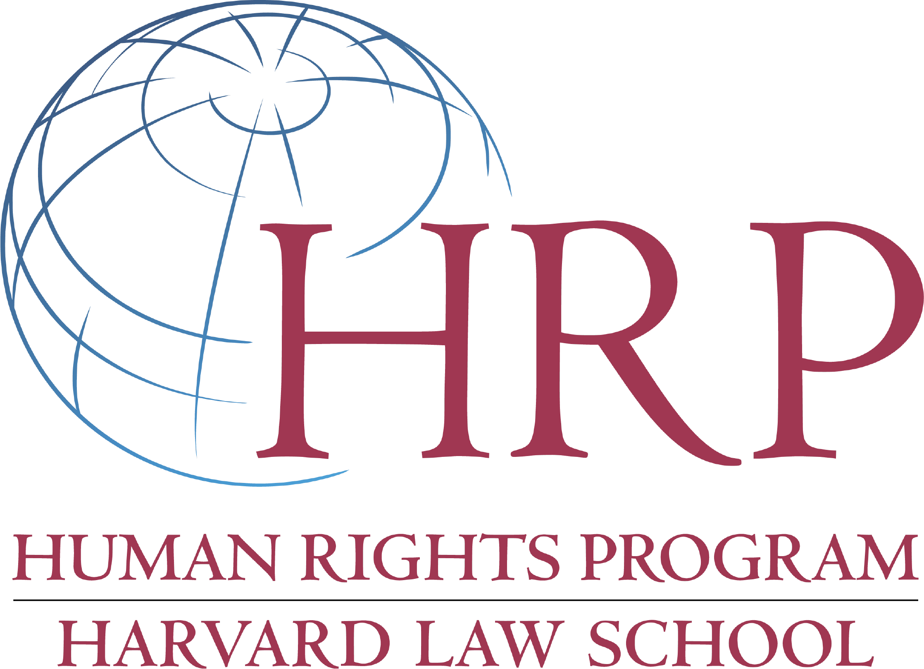

Satter Human Rights Fellowships

The deadline for submitting applications for
the 2018-2019 Satter Human Rights Fellowship is due March 19, 2018.
Contact with Advisors, Tyler Giannini and Emily Keehn, is required by February 16, 2018.

Description and Purpose of the Fellowship
The Human Rights Program (HRP) at Harvard Law School (HLS) offers one to three fellowships annually to work with organizations promoting human rights defense in response to mass atrocity or widespread and severe patterns of rights abuse. The fellowship has been made possible by a generous gift by Muneer A. Satter (’87).

The Satter Human Rights Fellowship focuses on human rights violations in countries classified as “Not Free” (rated 7) in the Freedom House index. The fellowship is limited to work on the following areas: 1) situations of mass atrocity; 2) situations of widespread and severe violations of human rights such as crimes against humanity that may be associated with civil conflict, failed states, authoritarian leaders or other highly repressive regimes; 3) situations of transition in the aftermath of conditions that meet the criteria outlined in (1) or (2). Preferred fellowship locations are for work in the Middle East and Africa. Other locations (e.g., Myanmar) that meet the above criteria may also be considered.

The Satter Human Rights Fellowships are for HLS students with a demonstrated commitment to international human rights and an interest in working in the field. They are intended to enable students to make a significant contribution to addressing human rights violations involving mass atrocities and similar situations during the year of the fellowship and to help students develop careers in human rights.
The Satter Human Rights Fellowships are intended to enable students to make a valuable contribution to human rights in an extreme situation during the year of the fellowship and to help students build human rights work into their careers. The fellowship carries a stipend of up to $45,000 for the twelve-month fellowship period.
Eligibility
Eligible Individuals: HLS students expecting to receive a JD degree in June 2018, as well as recent JD graduates are eligible. HLS LLM students who expect to receive a LLM degree in 2018 are also eligible. HLS JD and LLM 2018 graduates are given preference for the Satter Human Rights Fellowship. Similarly, applicants who have not received previous post-graduate fellowship funding from HLS are given preference.

Eligible Locations: Fellows must be either based in the “not free” countries where their work is focused, or be based in a neighboring country to be eligible. Under no circumstances may fellows be placed in Europe or the United States.

Eligible Organizations: The fellowship contemplates active participation in the work of a nongovernmental, governmental, or intergovernmental organization. The fellowship is not intended to support research at an academic or similar institution.

Application
Applications should be submitted to HRP by March 19, 2018 to hrp@law.harvard.edu. A complete application will consist of the following:

- Curriculum vitae, including information about classes, work, and extracurricular activities in public interest and human rights inside and outside HLS;

- A personal statement (500 words maximum) about the applicant’s relevant experience, interest, and future aspirations with respect to public interest and human rights work. The statement should include a discussion of how the fellowship fits within the applicant’s career plans. The statement should clearly indicate whether the applicant wants to be considered for the Satter Fellowship only, or for both the Satter and Henigson Fellowships.;

- A project description (see below for project requirements) including:

  - a description of the sponsoring organization and of its work in the local and international context;
  - a detailed discussion of the applicant’s project and its relation to the work of the organization; and
  - an estimated project budget to demonstrate feasibility;

- A letter and supporting material from the sponsoring organization detailing their purpose, function, and their particular interest in the work of the applicant;

- Two or three letters of recommendation, including at least one from a HLS professor; letters of recommendations may be submitted separately from the rest of the application to hrp@law.harvard.edu; and

- HLS transcript.

Fellowship Advising and Selection Process
HRP will oversee the administration of the fellowships, including through advising and selection. The HRP advisors are not part of the selection committee.

Advising: HRP will advise students preparing applications on the substance of their proposal, including whether particular sponsoring groups qualify and whether a placement meets the requirements for eligibility.

Applicants should contact Professor Tyler Giannini (giannini@law.harvard.edu) and Emily Keehn (ekeehn@law.harvard.edu) as early as possible (and no later than February 16, 2018) to discuss their placements. Professor Giannini or another member of HRP must speak with host organizations as part of the application process to ensure placements meet the requirements of the fellowship. Project descriptions should be as detailed as possible, and include specifics on how the placement is focused on mass atrocities.

Selection: HRP may seek to supplement the application with information from the applicant or other informed sources. Interviews may be required for finalists. The Selection Committee awarding the fellowships is not required to award any fellowships in the absence of sufficiently qualified applicants.

A final determination of whether a project proposal conforms with eligibility requirements will be made by a selection committee established for the purpose of awarding the Satter Fellowship. The selection committee will be comprised of HLS faculty members, senior administrators and staff.

The Selection Committee will give particular weight will be given to:

- The applicant’s relevant experience, including academic experience, extracurricular activities, and work experience that evidence a high capacity for and commitment to human rights work and the proposed project;

- The merit and feasibility of the applicant’s project, including the capacity of the proposed organization or organizations to host the applicant and make valuable use of his or her work; and

- The relevance of the project for the career plans of the applicant.
Funding Amounts and Restrictions
Fellowship awards are made without regard to financial need. The full fellowship carries a stipend of $45,000 for the twelve-month fellowship period. HRP may reduce the amount of the Satter Fellowship to correspond to other grants. Fellows are required to keep HRP informed of additional funding.
For More Information
For more information on the Satter Human Rights Fellowships, please visit the Human Rights Program website or contact:
Human Rights Program
Harvard Law School
WCC Clinical Wing, Third Floor
Cambridge, MA 02138
Phone: 617-495-9362
Email: hrp@law.harvard.edu

